
Timeline of the French Revolution
1789 1790 1791 1792 1793 1794 1795 1796 1797 1798 1799 1800 1801
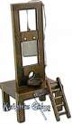

NN n
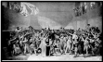
National Assembly
Years: May 5 to July 17, 1789

Accomplishments:

Significant Events:

Leading Players

Legislative Assembly
Years:
Oct 1, 1791 to
Sept 20, 1792

Accomplishments:

Significant Events:

Leading Players

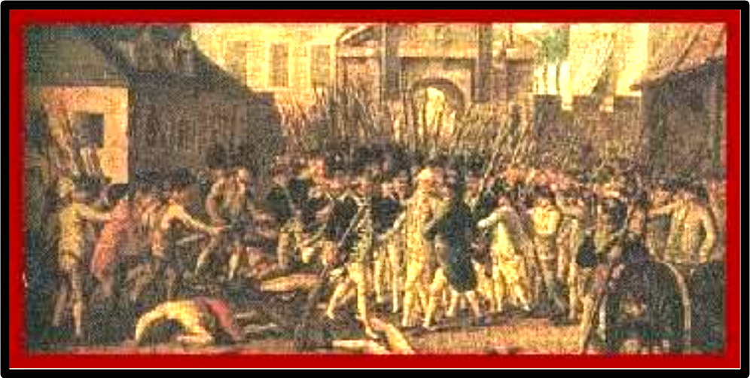
The Directory
Years: Oct 27, 1795 to
Oct 26, 1799

Accomplishments:

Significant Events:

Leading Players


Consulate
Years:

Accomplishments:

Significant Events:

Leading Players

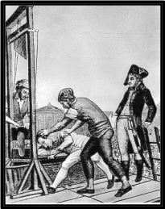
The Convention or
National Convention
Years: Sept 21, 1792 to
October 26, 1795

Accomplishments:

Significant Events:

Leading Players


Ancien
Regime

Accomplishments

Significant Events:

Leading Players
Constitutent National Assembly
Years: July 9, 1789

Accomplishments:

Significant Events:

Leading Players

Thermadore Reaction
1
8
0
4

N
A
P
O
L
E
O
N

E
M
P
E
R
O
R

